User Registration & Login Functionality – Facebook Application
- BRS – Business Requirement Specification / CRS ( Customer Requirement Specification )
Project Title:
User Registration & Login – Facebook Application
🔹 Business Objective:
Enable users to create accounts and securely log into Facebook to access platform features.
🔹 Business Requirements:
- Users must be able to create a new account.
- Users must be able to log in using credentials.
- Users must be able to reset forgotten passwords.
- System must ensure secure authentication.
- System must prevent unauthorized access.

🔹 Stakeholders:
- Facebook Product Team
- Security Team
- Development Team
- Service Provider Team
🔹 Business Benefits:
- Increase user base
- Secure user data
- Improve user experience
- Enable personalized services

- SRS – Software Requirement Specification
1. Functional Requirements
🔹 Registration
- User can register using:
  - First Name
  - Last Name
  - Email or Mobile Number
  - Password
  - Date of Birth
  - Gender
- System must validate email/mobile uniqueness.
- System must send OTP/email verification.
- Password must meet security criteria.
🔹 Login
- User can log in using:
  - Email/Mobile
  - Password
- System must validate credentials.
- Show error for invalid login.
- Provide "Forgot Password" option.
🔹 Password Reset
- User can reset password via OTP/email link.

2. Non-Functional Requirements
Type | Requirement
Performance | Login response time < 2 seconds
Security | Password must be encrypted
Availability | 99.9% uptime
Scalability | Support millions of users
Usability | Simple and user-friendly UI

3. Constraints
- Must support mobile and web platforms.

- FDD – Functional Design Document
1. User Registration Flow
- User clicks "Sign Up"
- User enters required details
- System validates inputs
- System sends verification OTP/email
- User verifies account
- Account successfully created

2. Login Flow
- User enters email/mobile and password
- System validates credentials
- If valid → Redirect to home page
- If invalid → Show error message

3. Business Rules
- Email must be unique.
- Password must contain:
  - Minimum 8 characters
  - 1 uppercase letter
  - 1 number
- Account locks after 5 failed attempts.

- UI Screens

- Registration Screen
- Login Screen
- Forgot Password Screen
- OTP Verification Screen
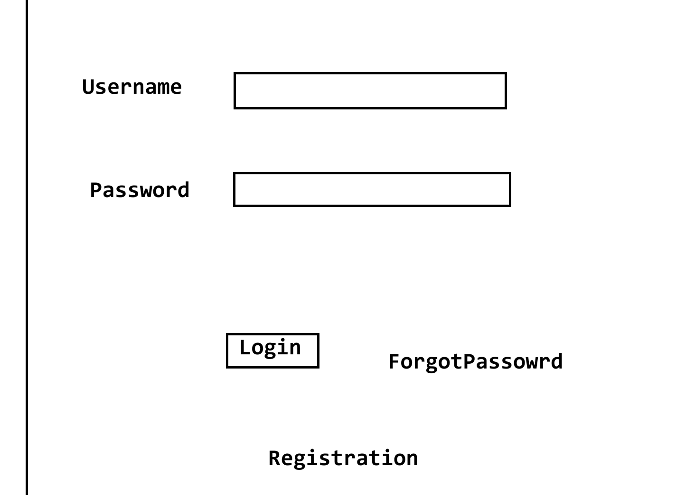

- TDD – Technical Design Document
1. System Architecture
- Frontend: React / Mobile App (iOS/Android)
- Backend: Node.js / Java Spring Boot
- Database: MySQL / PostgreSQL
- Authentication: JWT Token
- Encryption: Password Hashing Technique

2. Database Design
🔹 Table: Users
Field | Type
user_id | INT (Primary Key)
first_name | VARCHAR
last_name | VARCHAR
email | VARCHAR (Unique)
mobile | VARCHAR (Unique)
password_hash | VARCHAR
dob | DATE
gender | VARCHAR
created_at | TIMESTAMP
status | ACTIVE / INACTIVE

3. API Design
🔹 Register API
POST /api/register
🔹 Login API
POST /api/login
🔹 Forgot Password API
POST /api/forgot-password
🔹 Reset Password API
POST /api/reset-password

4. Security Design
- Password stored in hashed format (BCrypt)
- HTTPS communication
- JWT-based authentication
- Account lock after 5 failed attempts

Complete Flow in SDLC
BRS → SRS → FDD → TDD → Coding → Testing → Deployment

Summary
- BRS – Defines business need (Why?)
- SRS – Defines system requirements (What?)
- FDD – Defines system functionality (How it works?)
- TDD – Defines technical implementation (How it is built?)
V1.1
V1.2

